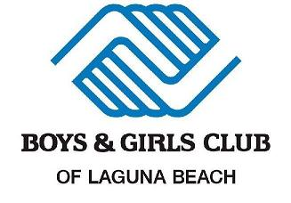

Parent & Guardian Club Safety Handbook

Contents

Welcome 2

Locations 2

Club Closures 3

mandatory Emergency Information 3

Member and Parent/ Expectations 5

CLUB PROGRAM POLICY 5

LATE PICK- UP POLICY 5

MEMBER EXPECTATIONS 5

Inclusion of All Children 5

BULLYING POLICY 6

Member Code of Conduct 6

Parent / Guardian Code of Conduct 7

MEMBER Discipline POLICY 7

COMMUNICATION WITH THE SCHOOLS 7

OUTCOMES MEASUREMENT 8

MENTORING PROGRAM 8

Health Policy 8

health concerns 8

Peanut and Tree Nut Free 8

Transportation Policy 8

YOUTH VENDOR PICK UP SERVICE 8

Program Spaces 9

Field Trip Policy 9

PERMISSION TO PHOTOGRAPH 9

TECHNOLOGY CONDUCT 9

ATHLETICS DEPARTMENT 10

RESTROOM POLICY 10

Culture of Safety 10

Staff Code of Ethics 10

Safety Committee 11

Immediate Reporting 11

SAFETY PROCEDURES 11

Emergency Operations Plan 12

Safety resources 15

Parent or legal guardian consent and acknowledgement form 1 of 2 20

Parent or legal guardian consent and acknowledgement form 2 of 2 21

# Welcome

Welcome to the Boys & Girls Club of Laguna Beach! GREAT futures start here. We are thrilled about helping your child grow socially, emotionally, educationally, and physically while participating in our programs. We are everyday mentors, First Aid & CPR certified, and are trained in youth development focusing on five core areas: The Arts, Education, Health & Wellness, Leadership & Service, Sports & Recreation to promote a sense of competence, usefulness, and belonging. Our Activity Leaders along with our Directors mentor each child using the 40 Developmental assets from the Search Institute making sure that each “Members” experience here at the Club promote healthy decisions, create empowerment and set boundaries and expectations. This handbook has been prepared to let our parents & guardians know of our safety policy and procedures while your child attends our enrichment programs. Please read carefully especially sections where consent and acknowledgment initials are required (* ).

# 

# Locations

**Canyon Branch**

1085 Laguna Canyon Road Laguna Beach, CA 92651

949. 494.2535

**Bluebird Branch**

1470 Temple Terrace Laguna Beach, CA 92651

(949) 494.7630

**The Port**

21547 Wesley Drive, Laguna Beach CA, 92651

(949) 549.4016

**El Toro Park**

23701 Los Alisos Blvd, Lake Forest, CA 92630

(949) 358.9331

**Oxford SBV**

22882 Loumont Dr, Lake Forest, CA 92630

(949) 554.4794

**Oxford SOC**

23000 Vía Santa Maria, Mission Viejo, CA 92691

(949) 554.4514

# Club Closures

Veteran`s Day

Thanksgiving Break

Winter Break (fourth week in December)

Martin Luther King Jr. Day

President`s Day

Memorial Day

Independence Day July

Staff Development June (Second week of June)

Staff Development August (Third week of August)

Labor Day

*\**Schedule and times are subject to change. Please visit our website for more information: [www.bgclagunabeach.org](http://www.bgclagunabeach.org)

**Stay Connected**

FacebookBoysGirlsClubLagunaBeach Twitter bgclagunabeach Instagram bgclagunabeach

Email: [info@bgclaguna.org](mailto:info@bgclaguna.org) [www.bgclagunabeach.org](http://www.bgclagunabeach.org)

**Mission Statement**

To INSPIRE and EMPOWER all young people, especially those who need us most, to reach their full potential as healthy, caring, responsible adults.

mandatory Child Emergency InformationReturn form to Boys & Girls Club of laguna beach

________________________________________________________________________________________________________________

Child/ Youth Legal First & Last Name Middle Name D.O.B Grade

_________________________________________________________________________________________________________________

Address City Zip

_________________________________________________________________________________________________________________

Father or Legal Guardian Cell Phone Email

_________________________________________________________________________________________________________________

Mother or Legal Guardian Cell Phone Email

This Child lives with: Both Parents Mother Father Stepparent or Guardian

Primary Language: _________________________ Secondary Language________________________________

The Boys & Girls Club of Laguna Beach has my permission to release my child/ youth to the following individual (s) or to the proper medical personnel, if an emergency (medical or other) renders me incapable of caring for my child. (Be sure that at least one contact is a local resident.)

__________________________________________________________________________________________________________________

Name Relationship Telephone Number

___________________________________________________________________________________________________________________

Name Relationship Telephone Number

Specify any persons to whom your child is not to be released. Complete official court papers must be on file in office if a person is not to pick up child during club hours.

___________________________________________________________________________________________________________________

**Emergency Release / Authorization to Treat**

If, in the judgment of the staff of the Boys & Girls Club of Laguna Beach, the child named above needs immediate care and treatment as a result of any injury or sickness, I hereby give permission to the staff to secure proper treatment for my child. I do hereby consent to whatever x-ray, examination, anesthetic, medical, surgical or dental diagnosis or treatment and hospital care are considered necessary in the best judgment of the attending physician, surgeon or dentist and performed by or under the supervision of the medical staff of the hospital or facility furnishing medical or dental services. It is further understood that the undersigned will assume full responsibility for any such action, including payment of costs. I do hereby agree to indemnify and hold harmless the Boys & Girls Club of Laguna Beach (including its officers, directors, members and/or volunteers) from any claim by any person whomsoever on account of such care and treatment of said child.

_________________________________________ _________________________________________ ____________________

Parent / Guardian Name (Printed) Parent / Guardian Signature Date

Emergency Health Information: Does listed child have health problems? No Yes

Please explain. ____________________________________________________________________________________________

If persons listed on this card cannot be reached, medical care may be obtained from physician or emergency hospital or paramedic: YES NO

Allergies: Specify if any ________________________________ Asthma Bee Sting Severe Allergy

Diabetic Seizures Convulsions Nut Allergy Dairy Allergy

Medications: _____________________________________________________________________________________________________________

# Member and Parent/ Expectations: * Acknowledgement Initials Required

# The Boys & Girls Clubs of Laguna Beach strives to maintain a Club environment that is built on respect for all. As such, there is a zero-tolerance policy for behaviors or actions that jeopardize the health, safety, and well-being of any individual(s) being served or employed by the organization; this includes but is not limited to other parents, members, staff, volunteers, and partners of the organization.

Boys & Girls Club of Laguna Beach does reserve the right to terminate any membership based on the behavior of the parent/guardian. Negative behavior by a parent/guardian will be viewed as a violation of organizational policies and will be addressed immediately with actions up to and including suspension or termination of membership. In an instance in which membership is terminated for violation of organizational policies by the parent or child, no refund will be administered.

All members and youth attending or participating in Boys & Girls Club of Laguna Beach programs and activities must be able to comply with Membership Safety and Inclusion policy, along with member rules and expectations. Members and youths’ ability to comply with these guidelines helps to ensure that all participants are able to receive a quality Club experience. Failure of any member or youth participant to comply with these expectations may result in implementation of the Boys & Girls Club of Laguna Beach disciplinary policy and may result in escalating consequences which may result in suspension or termination of membership.

CLUB PROGRAM POLICY**: * Acknowledgement Initials Required**

Every member participating in the Boys & Girls Club of Laguna Beach Is required to have an active membership or waiver signed by a parent/ legal guardian before participating in any Club related activity or volunteer project.

As defined by the State of California, Department of Social Services, Community Care Licensing Division, which allow members to arrive and leave the facility at their own leisure. We are not a licensed day care but a **private recreation** **program.** Our staff does not grant permission for children to leave the Club, nor do we insist that they stay. The decision as to when a child arrives and leaves the Club, and with whom, is a matter between the parents and the child. If a child leaves the Club without adult supervision, **the parents take full responsibility for the child’s action** while the child/youth is unsupervised. We are responsible for the safe and proper use of the facility and the equipment and obligated to create an environment in which our participants behave appropriately according to Club rules. If it is the parent’s desire that the child remain at the Boys & Girls Club of Laguna Beach until picked up be a designated person, the responsibility for this lies solely with the parent and the child/youth. The Boys & Girls Club of Laguna Beach will not be held liable should any child/youth leave the premises without permission. **We highly recommend that you tell your child/youth to stay at the Boys & Girls Club until parent or guardian picks them up.**  We will strongly remind your child/youth of your wishes.

LATE PICK- UP POLICY**:** **\*Acknowledgement Initials Required**

Club membership is a privilege, and everyone must abide by the rules. During the **school year** the **Canyon Branch closes at 6PM Mon-Fri**, during the **summer** the **Canyon Branch closes at 6PM**. During the **school year** **Bluebird Branch closes at 5:30PM Mon-Fri**, during the **summer** **Bluebird Branch closes at 5PM Mon-Fri**. During the **school year** **El Toro Park closes at 6PM Mon-Fri**, during the **summer** the **El Toro Park closes at 5PM Mon-Fri.** During the **school year** **Oxford SOC and SBV Center closes at 6PM Mon-Fri**, during the **summer** **Oxford SOC and SBV Center closes at 5PM Mon-Fri.** **The Port closes at 7PM Mon-Fri** unless scheduled to close at a later time for events. Late slip warnings will be given out and documented. After the 3rd warning slip and the parent/guardian is continuously late and are unable to pick your child up by closing time, The Boys & Girls Club Membership will then be evaluated by the Branch Director and may result in suspension or termination of Membership.

MEMBER EXPECTATIONS**: *Acknowledgement Initials Required**

Our Members are expected to be safe, responsible, respectful, and great. Members are always to stay in designated areas and speak calmly and respectfully to all Members and Staff. Our staff is here to protect all Club Members from physical and emotional harm. Behavior that teeters away from the expectations is subject to loss of participation in all CLUB activities, which includes but is not limited to: Field Trips, Special Events, Sports leagues, and Daily Attendance. Depending on the severity of the behavior, a one to five-day suspension will occur. Boys & Girls Club of Laguna Beach requires that all members always display appropriate behavior.

# Inclusion of All Children (Anti- Discrimination and ADA Statement): *Acknowledgement Initials Required

Boys & Girls Club of Laguna Beach embraces diversity and welcomes all children without regard to national origin, race, creed, religion, gender expression, disability, or handicap. All children and youth are accepted into our enrichment programs as long as we are able to provide a program and environment that meet the needs of the child/youth enrolled.

The child/youth must not endanger themselves, other enrolled members or staff. Our Club will make reasonable accommodations for children/youth with disabilities and special needs as described by the Americans with Disabilities Act. The Club may require that a trained ABA therapist or shadow support is necessary for your child/youth to help in the development of their social, and behavioral skills while in a Club social environment. The ultimate goal is to encourage the continuation of positive behaviors that have been learned. Positive reinforcement that can help increase completion of tasks or social interactions. Maintaining functional and socially appropriate behaviors, teaching self-control or self-monitoring techniques in different settings. An ICP meeting will be scheduled with the Boys & Girls Club of Laguna Beach COO, and or the Achievement and Wellness Director to ensure your child/youths safety.

BULLYING POLICY: **\*Acknowledgement Initials Required**

Boys & Girls Club staff shall establish Member safety as a high priority and shall not tolerate bullying and or cyberbully of any Member. If a Member’s behavior involves but is not limited to: harassing communications, threats, physical altercations, harmful texts, use of internet images, social media, uses racial slurs. That Member will be suspended without the need for previous write ups. This is a no bullying tolerance policy. When cyber bullying occurs individuals with information are highly encouraged to save and print any electronic or digital message, they feel constitute cyber bullying and to notify a STAFF Member to help resolve the incident.

Member Code of Conduct**: *Acknowledgement Initials Required**

1. All members must sign in and out with a staff member and front desk staff.

2. To ensure members’ safety, members must remain within designated boundaries and are required to enter and exit through the front door only.

3. **All cell phones for youth in grades kinder – 8th grade must keep their cell phones in their backpacks while they are at the Club.**

* 1. Phone use by staff permission at the front counter for emergency calls to parents/guardians only.

**Inclusion Program (youth with educational, physical, mental, social & emotional challenges)**

* 1. Individual meeting (Individual Club Plans) with parents/guardians/youth to understand device needs due to coping strategies
  2. **Rules Agreement between all involved the use of club device(s) by youth at club.**

**Consequences the same for all grades:**

* 1. First Offense: Ask for the phone, lock in secure area (front desk or Area Director’s Office) and give phone back to child/youth when they go home.
  2. Second Offense: Ask for the phone, lock in secure areas (front desk or Area Director’s Office) and call to parent/guardian. Phone will be issued when youth goes home.
  3. Third Offense: Lock phone in secure areas (front desk or Area Director’s Office) and phone will be released to parent/guardian at pick up.
  4. Fourth Offense: Strong consideration to expel from program

4. **Members are not allowed in any office areas.**

5. Personal toys, electronics, are not allowed in the Club. **Parents/guardians and members are responsible for any valuables/money brought to the Club.**

6. All members and parents/guardians are expected to be kind and respectful while in the Club. Profane language, name-calling, teasing, bullying, horseplay, fighting, and/or stealing will not be tolerated and may result in suspension.

7. If members cause damage to Club equipment, the parents are responsible for the cost of repair or replacement.

8. Gum chewing is not permitted anywhere in the Club.

9. For members’ safety, bare feet, sandals, flip-flops, and open toed shoes are not allowed to be worn at the Club.

10. For members’ safety, running is only permitted outside or in the Gym.

11. Members should respect their environment and are responsible for keeping their Club clean, including cleaning up after themselves and throwing away trash in the appropriate containers.

12. For safety reasons, rollerblades, skates, skateboards, bikes, shoes with wheels and hover boards are not permitted at the Club unless specified by program.

13. In case of an emergency and for your child’s protection, please be sure to keep membership and emergency card information updated.

14. All facilities, properties, grounds and events are non-smoking and drug free. Alcohol, weapons, non-prescription drugs and any other substances are strictly prohibited.

15. **Dress Code:** Clothing must be modest in keeping with school’s dress code policy. Revealing shirts, shorts or dresses* must be at fingertip length, offensive attire that defames, degrades, or is offensive to a gender, race, color, and religious creed, sexual orientation is not allowed to be worn at the CLUB.

16. Sexual references, drug or alcohol references, graphic violence, racial slurs, and profane language will not be allowed.

17. Parent/ Guardian will be notified if their youth displays inappropriate or unacceptable behavior. If the youth does not correct his/her behavior, an ICP (Individual Club Plan) meeting will be scheduled with the Achievement Wellness Director.

# Parent / Guardian Code of Conduct: *Acknowledgement Initials Required

The Boys & Girls Clubs of Laguna Beach strives to maintain a club environment that is built on respect for all. As such, there is a **zero tolerance policy** for any derogatory or disrespectful behavior exhibited by parents / guardians during any organization related interaction. This includes the following examples but not limited to:

* Physically or verbally engaging in any negative manner while on Club grounds.
* Attempting to interact negatively with other children / parents or guardians (this includes attempts to address any behavioral concerns involving another Member).
* Refusing to adhere to organizational policy and procedure.
* Entering any organization facility under the influence of drugs / alcohol.
* Drinking, Smoking or utilization of tobacco products on organization property.
* Habitually arriving late to pick up a child(ren).
* Speeding through parking lot, after being warned or reminded about the dangers.
* Failure to comply with organization fee collection policy.
* Behavior or actions that violates federal, state, or local laws and/or ordinances.

Any other actions that present a challenge to the organization’s ability to operate in a safe and positive fashion. This is assessed at the discretion of the Boys & Girls Club of Laguna Beach Chiefs with additional oversight from administrative staff. Volunteers, parents and guest must check in at the front reception area as well as put on an identifiable badge upon entering the Club or Clubhouse.

Please note that the Boys & Girls Clubs of Laguna Beach reserves the right to terminate any membership based on the behavior of the parent / guardian. Negative behavior by a parent / guardian will be viewed as a serious violation of organizational policies and will be addressed immediately with consequences up to and including suspension / termination of membership. In the instance of a membership termination due to parent / guardian behavior, a refund will not be issued.

MEMBER Discipline POLICY**:** **\*Acknowledgement Initials Required**

1. If a Club Member is suspended from school the Member is not allowed to attend the Boys & Girls Club of Laguna Beach until the suspension is lifted. Once the suspension is lifted our Achievement Wellness Director will meet with the parent/ guardian regarding an ICP (Individual Club Plan) in order to resume Club attendance.
2. Only the Achievement Wellness Director will discuss with the Parent/ Guardian the member’s behavior and implement an ICP (Individual Club Plan).
3. A Club member will not be suspended from the Club without notifying the parent/guardian.
4. Only the CEO/COO and Achievement Wellness Director will decide to suspend or expel a member from the Club.

**EXAMPLES BUT ARE NOT LIMITED TO THE FOLLOWING:**

1. Verbal Warning: Profanity, Inappropriate joke/content
2. Parent/Guardian Notification: Verbal written Altercations, Disrespectful Behavior, Destruction of property.
3. Suspension: Physical Altercation, Paraphernalia/Devices, Use /Possession or Distribution
4. Expulsion: Repetitive or excessive behavior that causes unsafe Club environment or harm to Members, staff or self.

**Note: Parent/Guardian(s) will be required to have a meeting with our Achievement Wellness Director to ensure our Members safety. An ICP meeting consists of: Suspensions, Behavioral Challenges, Social and Emotional services at the Club.**

COMMUNICATION WITH THE SCHOOLS: **\*Acknowledgement Initials Required**

In order to promote school and life success and work in collaboration with the schools, the Boys & Girls Club of Laguna Beach exchanges program information to your child’s school district (LBUSD, CUSD or SVUSD) any or all social, psychological, medical, speech/language and educational information regarding your child. Effective until revocation in writing has been delivered to Boys & Girls Club of Laguna Beach.

OUTCOMES MEASUREMENT**: *Consent Initials Required**

Boys & Girls Club of Laguna Beach Mentors, surveys and interviews all members, to find out what his/her behaviors, skills and attitudes are in regards to issues such as health risks, habits, positive self-esteem, respect for diversity, education and educational resources, positive relationship, career choices, and connection to community, as well as his/her experiences at the Club. The purpose of our mentoring program, surveys and interviews is to help find out how well the Club is meeting your child’s needs and to identify areas which may call for further attention. The information gathered will remain private and only your child’s Club Director and assigned research assistants will be able to look at his/her responses.

All members who are surveyed and have responses will be automatically grouped together with the response of other Boys & Girls Clubs members for any public presentation of the findings, your child will never be individually linked to his/her responses.

MENTORING PROGRAM**: * Consent Initials Required**

Mentors shall be selected and screened (including criminal background check) and trained before beginning the program. Mentees will also attend an orientation where the mentoring program will be explained. Boys & Girls Club Mentoring Program has my legal consent and gives permission for my child to participate in Boys & Girls Club mentoring program. Additional information regarding the program will be sent out for parent or legal guardian review.

Health Policy**: * Acknowledgement Initials Required**

If your child in unable to attend school due to illness or has been sent home, we ask that you do not drop them off at the Club. Please be considerate of this especially during cold and flu season. In the same regard, if your child has lice, they may not attend the Club until they are completely knit-free. Treatment periods, school policies and doctor’s notes are not valid reasons for attendance if there are lice knits present.

**Local or Environmental Health GUIDELINES: * Acknowledgement Initials Required**

In the event that there is a local, regional, or national health emergency, Boys & Girls Club of Laguna Beach may be required to modify its regular procedures by adding more rigor, regulations, and/or restrictions to ensure its ability to safely operate its facilities and programs. Any process implementation may require an escalation in its administration and/or frequency of administration. All process implementation is done in accordance with organizational policy, and an adherence to local, state, and federal laws and ordinances, including but not limited to anti-discrimination, ADA compliance, Child Abuse and Neglect, and Health Insurance Portability and Accountability Act of 1996 (HIPAA). Please Note: Due to the COVID-19, novel coronavirus, additional protocols and guidelines are enforced and are mandatory for any and all individuals prior to entering a Boys & Girls Club of Laguna Beach and Saddleback Valley facilities and programs. Boys & Girls Club of Laguna Beach will continue to follow guidance from CDC, OCHCA, OSHA regarding public health protocols. While Boys & Girls Club of Laguna Beach will take added precautions to safeguard all staff and children in our care, by submitting an application for membership, each parent or guardian acknowledges that COVID-19, coronavirus could still pose a serious health risk to you and your family. The ability to safely serve every child is the number one priority of Boys & Girls Club of Laguna Beach.

**ASSUMPTION OF THE RISK AND WAIVER OF LIABILITY RELATING TO COVID-19: * Acknowledgement Initials Required**

Boys & Girls Clubs of Laguna Beach has put in place preventative measures to reduce the spread of COVID-19. These include, but are not limited to, [wellness monitoring, increased sterilization, and frequent hand washing] However, the Club cannot guarantee that you or your child(ren) will not become infected with COVID-19. Further, attending the Club could increase your risk and your child(ren)’s risk of contracting COVID-19. By enrolling, I acknowledge the contagious nature of COVID-19 and voluntarily assume the risk that my child(ren) and I may be exposed to or infected by COVID-19 by attending the Club and that such exposure or infection may result in personal injury, illness, permanent disability, and death. I understand that the risk of becoming exposed to or infected by COVID-19 at the Club may result from the actions, omissions, or negligence of myself and others, including, but not limited to, Club employees, volunteers, and program participants and their families. I voluntarily agree to assume all of the foregoing risks and accept sole responsibility for any injury to my child(ren) or myself (including, but not limited to, personal injury, disability, and death), illness, damage, loss, claim, liability, or expense, of any kind, that I or my child(ren) may experience or incur in connection with my child(ren)’s attendance at the Club or participation in Club programming (“Claims”). On my behalf, and on behalf of my children, I hereby release, covenant not to sue, discharge, and hold harmless the Club, its employees, agents, and representatives, of and from the Claims, including all liabilities, claims, actions, damages, costs or expenses of any kind arising out of or relating thereto. I understand and agree that this release includes any Claims based on the actions, omissions, or negligence of the Club, its employees, volunteers, agents, and representatives, whether a COVID-19 infection occurs before, during, or after participation in any Club program.

health concerns**: * Acknowledgement Initials Required**

It is imperative that when signing up and filling out the emergency form that the parent/guardian lists any allergies, food, medication and or any health concerns which may affect your child’s well-being. Boys & Girls Club of Laguna Beach does not dispense medications. Prescription medication must include written instructions from a physician and must be self-administered. If your child has a condition in which medication is self-administered, special arrangements need to be made with the Branch Director at your site. The Club does not provide refrigeration for medication.

Peanut and Tree Nut Free**: * Acknowledgement Initials Required**

All snacks served by the club are **peanut and tree nut free**. We also ask that no peanut or tree nut products be brought into the Club. Foods that are sent in for snack or lunch should be carefully checked to make sure they do not indicate that they “*contain or may contain peanuts or tree nuts.”* nor may they be “*made in a facility or on equipment that* *processes peanuts or tree nuts*.” The Club does not provide refrigeration to store food and or a microwave.

Transportation Policy**: * Acknowledgement Initials Required**

The Canyon Enrichment Center offers afterschool transportation to selected schools, please check our website for additional information. A transportation contract must be signed in order to be placed in the program. If members have behavior problems during their trip to the Club the parent/guardian will be notified of the mandatory consequence or if incident is severe enough to suspend the transportation service with only first or second offense. Ratio guidelines are instilled during transportation routes, at no time will the member ride with only one staff present. Two members of staff are to be present while the transportation route is in session. This ensures the safety of our members, and staff while our transportation service is in route.

YOUTH VENDOR PICK UP SERVICE: **\*Acknowledgement Initials Required**

Parent/Guardian must give a written consent notice with the days of the week the Club member will be getting picked up by a service such i.e.(HopSkipDrive). Drivers must follow Club guidelines such as driving speed limit through our parking lot, checking in at the front desk as well as signing the Club member out. The Parent/Guardian is responsible to notify the Club of any changes should any additional days be added and or terminate the service for our records. If the parent/guardian would like to utilize any different services, the parent/guardian must get approval by the Clubs Executive Team in order to ensure our Clubs safety.

**Elevator Policy:**

Members shall not ride in the elevator unless there is a a medical reason or a physician’s note provided by the parent/guardian to use the elevator. At no time will a member ride by themselves and will need to be escorted by a member of staff along with an additional rider.

# 

# Program Spaces: *Acknowledgement Initials Required

**In all areas of the facility and in all activities, members are to stay within designated boundaries. Members are not permitted to go into closets, office spaces or be in a room or an area by themselves. Boys & Girls Club of Laguna Beach require staff and youth to utilize the “Rule of 3”.**

* 1. No one-on-one interactions between staff and youth or between two youth, in person or online.
  2. Two staff always maintain one-two or more youth in their care (including during drop-off and pick-up); two staff may be with one youth should the member arrive before other members or during late pick up.

Field Trip Policy**:** **\*Acknowledgement Initials Required**

Field trips are **NON-REFUNDABLE AND NON-TRANSFERABLE**; payment is due at time of sign up on “Parent Portal”. Each field trip has its **own mandatory emergency card** to be completed and turned in, in order to attend. *Members without a completed field trip **Emergency Card** will not be allowed to attend the field trip. **Members may not be dropped off and or picked up from field trips. Prepaid annual passes are not accepted as a form of payment.**

***No Exceptions!*** If members have behavior problems prior to the trip or during the trip the parent/guardian will be notified of the mandatory consequence which may include removing the member off the field trip list. Member may not attend any additional trips depending on the severity of the behavior incident. Members may not be dropped off at any trip that has already departed.

**THIRD PARTY PHOTOS: *Acknowledgement Initials Required**

Due to our Clubs privacy requirement: Our safety for all our staff and its Club members. We ask that all Parents, Club Members and Visitors refrain from using any device that can record and photograph within the Club and its grounds. Unless preapproved by the Branch Director for any club programing. Any Club Member, Visitor or Parent caught in the act may result in membership suspension or termination.

**PUBLIC FILMING & PHOTOGRAPHY OUTSIDE OF CLUB:** **\*Acknowledgement Initials Required**

By your child participating on any field trips or events outside of the Clubs premises, the parent or legal guardian understands that their child may be photographed, filmed, or videotaped and you the parent and or legal guardian hereby given permission for outdoor public exposure but is not limited to (club related field trips, city events, etc.). During these events the public has the unqualified right to take pictures and/or recordings of your child and grant the perpetual right to use your child’s likeness, image, photo (collectively, “image”), without compensation, for broadcast or exhibition in any medium and to put the finished pictures/recordings to any legitimate use without limitation or reservation. You the parent or legal guardian does hereby waive, release and forever discharge The Boys & Girls Club of Laguna Beach from and against any and all claims or actions arising out of or resulting from any use of your child’s image. The public shall not be obligated to use, and may elect not to use, your child’s image.

PERMISSION TO PHOTOGRAPH**: *Consent Initials Required**

Occasionally, Boys & Girls Club of Laguna Beach program activities may be photographed, videotaped, or audio taped for educational, publicity or fundraising purposes. Please indicate if you give permission for your child (ren) to appear in videos, photos or audio recordings without compensation (e.g., as part of brochures, slide shows or program websites).

**PHOTOGRAPH/ARTWORK: *Consent Initials Required**

Boys & Girls Club of Laguna Beach and the Art Director use member’s **artwork/photographs** and publishin print, audio, visual, or electronic meansfor building awareness and educational purposes. This may include, but is not limited to art education publications (Schools, Art magazine, Magazines, Newspapers, etc.), Club presentations, posts such as on arts and Club social media, and websites but not limited to (bgclaunabeach.org, Instagram, Twitter, snap chat, Facebook, Stu News, Nextdoor.

TECHNOLOGY CONDUCT**: *Acknowledgement Initials Required**

Misuse of cameras, cell phones, and any internet enabled devices may result in disciplinary action including membership termination. Misuse includes but is not limited to photographing members, staff, club property, inappropriate emails, texts, social media posts, etc. We **HIGHLY** discourage bringing in personal electronic devices as they are not allowed to be out during program hours.

ATHLETICS DEPARTMENT **\*Received Fact Sheets Initials Required**

CONCUSSION SPORTS & OPIOIDS FACT SHEETS (PG: 16-19)

The existing law requires an Organization who offers sports Leagues to obtain and give the legal parent/guardian a concussion and head injury information sheet along with the Opioid Factsheet. Annually the parent or guardian will sign off that they have physically received and or have been emailed the downloadable sheets before the member starts an athletic league.

RESTROOM POLICY: **\*Acknowledgement Initials Required**

**Canyon Branch:** Restrooms located at **Canyon Branch** (**Front Lobby, Preschool and Kinder Room**) have been designated for our **members** and are only allowed **one member at a time**.

**Bluebird Branch:** Restrooms located at **Bluebird Branch (Main Room)** have been designated for our **members and staff** and are only allowed **one person at a time**.

**The Port: The Port** have public restrooms shared by members, staff and the public. At no time will a member walk into a public restroom without the staff clearing the restroom first. Only one member or staff is allowed at a time.

**EL TORO PARK:** El Toro Park have single stall public restrooms shared by members, staff and the public. At no time will a member walk into a public restroom without the staff clearing the restroom first. Only one member or one staff is allowed at a time.

**OXFORD SBV and SOC:** Portables on campus, restrooms designed for students and faculty. Assigned restrooms for adults and students. Students use student restrooms and staff use staff restrooms. Afterschool hours, staff will open restroom for member or staff and will lock after every use.

1. Monitoring: includes walk-throughs, inspections and sanitizing restrooms after use by staff.
2. Staff shall only use designated adult restrooms with the exception of Bluebird Branch and The Port, El Toro Park, Oxford SBV and Oxford SOC. Should separate restrooms be unavailable, staff shall use restrooms at designated intervals to ensure they are not using restrooms at the same time as youth members.
3. Intervene and notify Club leadership should inappropriate conduct be observed
4. Document, in writing, restroom conduct incidents and report them to Club leadership as soon as possible.

Culture of Safety**:**

We implement layers of safety policies and guidelines to keep our members, staff, and volunteers safe including:

1. Staff and volunteer safety training
2. First-aid AED and CPR training
3. Dedicated Safety Committee
4. Yearly Mandatory Safety Assessments
5. Background and Fingerprint Checks: DOJ, Secure Live Scan, LBPD
6. Supervision, transportation, communication training
7. Mental Health First Aid
8. Sexual Prevention and Misconduct Prevention
9. Emergency Operations Plan
10. Barrier crime policy

**NON-SMOKING, ALCOHOL, WEAPONS & DRUG-FREE ENVIROMENT: *Acknowledgement Initials Required**

All facilities, properties, grounds and events are non-smoking and drug free. Alcohol, weapons, non-prescription drugs and any other substances are strictly prohibited on Club grounds.

Staff Code of Ethics**: *Acknowledgement Initials Required**

It is against our organization policy and Boys & Girls Club of America’s Code of Ethics, prohibits our staff to accept paid/contractual/unpaid services with our parents for their children, I.E.,

1. Babysitting
2. Coaching
3. Transporting
4. Tutoring
5. Other direct services or off-site contact

Former employees, the liability, responsibility and due diligence regarding background checks, etc. fall solely with the parents who choose to engage services for their children. **Any preexisting relationships between staff and Club families need to be documented by both parties. A record of interpersonal relationships needs to be kept on file as long as the member is currently enrolled with Boys & Girls Club of Laguna Beach.**

Safety Committee**:**

Boys & Girls Club of Laguna Beach has a Board Led safety committee to provide input and guidance on local policies and safety strategies. Priorities and initiatives include:

1. Background checks and fingerprints on all volunteers and employees including youth volunteers and youth employees
2. No one-on-one contact between a member and staff or member and member
3. Policy and Procedure
4. Risk Assessments

**Mandatory Background Checks:**

Mandatory criminal background checks and finger printing are required every year for every staff and board member at Boys & Girls Club of Laguna Beach In addition, criminal background checks are required for any volunteer who has direct contact with our members.

**State and Local Laws:**

We comply with federal, state and local safety laws, including those impacting our facilities and vehicles.

Immediate Reporting**:** **\*Acknowledgement Initials Required**

Boys & Girls Club of Laguna Beach are all mandated reporters. We are required to report any critical incident/safety concern to local authorities immediately, communicate with the legal parent or guardian regarding and Club incident.

**24-hour Toll-free Child Safety Hotline:**

We encourage all staff, members and families to report any incident or situation they feel is unsafe. Through our national partnership with Praesidium, one of the nation’s leading safety experts, Boys & Girls Club of Laguna Beach and staff have access to a confidential 24-hour toll-free Child Safety Hotline, 866-607-SAFE (7233) or email [SafeClub@Praesidiuminc.com](mailto:SafeClub@Praesidiuminc.com).

SAFETY PROCEDURES**:**

1. Staff Initiates immediate first aid action as necessary (Staff is First Aid/ CPR Certified)
2. Director calls 911 if the emergency is serious.
3. Staff contacts emergency contacts listed on Member registration. Parent/Guardian is informed on incident.
4. Staff documents incident. Staff informs Director of incident and communicates with Chief Executive Officer/ Chief Operations Officer.

**In the event that the club is evacuated, the following procedure is to be put into effect:**

1. Staff will call 911**.**
2. Staff will use our Club vans and shuttles and call the nearby *Transportation Company* to facilitate evacuation procedures.
3. Staff will grab emergency backpacks containing (Emergency forms or cards, First Aid Kits and Prescribed medication along with Doctors note requiring the child to carry medication).
4. Staff will evacuate all children to \***Crisis Reunification Center**, notification on location.
5. Crisis Release Form must be signed by parent/guardian/emergency contact in order for staff to release child. *Must be listed on Member Emergency Card or Form.

**Safety Monthly Drills:**

Club Staff will conduct and practice monthly safety drills with our members, volunteers and parent/guardian if on site. This ensures a sense of calm for our Members knowing that our Staff is well rounded and trained. Drills: Medical Emergency, Fire, Earthquake, Shelter in place, Flood, Evacuations. A notice will be posted outside when drills are in session. We ask that any parent/guardian that is picking up wait until the drill is over so our Staff can properly release the Member.

# 

# Emergency Operations Plan

**Staff Responsibilities:**

**GAS/ WATER SHUTOFFS:** All Staff

* Water
* Gas
* Electrical

**EMERGENCY BACKPACKS & ROSTER:** Department Supervisors

**EMERGENCY FORMS:** Member Services Department or Site Coordinator (Area Director/ Program Operations Director)

**FIRE DRILL REPORT:** Member Services Department or Site Coordinator (Area Director)

**EMERGENCY SUPERVISORS:** Club Safety Director and Risk Management Director (Area Director)

**SECONDARY SUPERVISORS:** Area Director (Program Operations Director or Site Coordinator)

**LINE-UP/ROLL CALL:** Program Directors, and any Available YDPs

**FINAL SWEEP/CHECK OF CLUB:** Program Operations Director, Area Director

**TRIAGE SPECIALIST:** Area Director (Program Operations Director, Directors, Capable YDP’s)

**LOCKDOWN:**

* **Code Green**- Soft lockdown, one program area closed.
* **Code Yellow**- Lockdown, members must be escorted in or out of program area.
* **Code Red**- Full lockdown, doors locked closed, lights off, everyone out of sight and silent.
* Gather emergency supplies (emergancy backpack/ bucket).
* Evacuation protocol may be required after code yellow or red lockdown.

MEDICAL & FIRST AID:

* Call 911 if the emergency is serious.
* Provide first aid.
* Don’t administer medication **ONLY ASSIST.**
* Summon assistance & Notify Supervisor.
* Complete incident report.

Triage w/ Mass Casualties:

* Triage before treatment
* Between 10 & 30 breaths per min, <2 sec capillary refill, can fallow simple directions = pass
* Minor: Walking wounded.
* Delayed: Passes 30/2 Can Do but still has significant injury.
* Immediate: Fails one or more of 30/2 Can Do.
* Desist: Individual is not breathing after 2 attempts to open airway.
* Use Casualty Card to record pertinent information.
* Treatment begins at secure location.

**WORKPLACE VIOLENCE:**

* Code RED/ Intruder is here signifies violent individual(s).
* Don’t evacuate to Fire Alarm.
* Code word required for entrance to a room or evacuation.

**Active Shooter:**

**Use best judgment to choose option to keep yourself and others safe.**

**RUN**

**HIDE**

**FIGHT**

* Once safe, create/report to secure location.

EARTHQUAKE:

* Drop , take cover & cover your head.
* STAY CLEAR of dangerious objects that can cause injury.
* If outside DONT RUN inside.
* Gather emergancy supplies (emergancy backpack).
* Evacuation protocol may be required after an earthquake.
* Once safe, create/report to secure location.

FIRE:

* Exstinguish fire **only if** time riquired is 5 seconds or less.
* PASS- Pull, Aim, Squeez, Sweep.
* If time required is >5 seconds call for help.
* Remove all individuals in danger and **CLOSE ALL DOORS** behind you.
* Gather emergancy supplies (emergancy backpack).
* Evacuation protocol may be required after a fire.
* Once safe, create/report to secure location.

BOMB THREAT:

**Phone Threat**

* Gather as much informatin as possible. Details about explosive as well as the caller.
* Alert other staff of threat via organe cation disk(reception area).
* Have other staff call 911
* Evacuation protocal required.

**Mail Threat**

* Call 911
* Evacuation protocal required.

**Suspicious Object**

* Dont touch object
* Call 911
* Evacuation protocol may be required after a suspicion object is found.

Sanitation Policy

**Basic**

* Always use personal protective equipment.
* Body fluids are disposed of in a double bag system.
* Isolate sick member.
* Inform parents or guardian.

**Infectious**

* Inform supervisor immediately
* Always use personal protective equipment.
* Member will be picked up as soon as possible.
* Sanitization of all in contact.
* In sever case contact authorities to determine severity.
* **Gym** is quarantine zone.
* Proceed to code red lock down.

**RESPONSE TO CRISIS/EMERGENCY EVACUATION**

* Call 911 if emergancy /if not call non-emergacny number.
* Gather emergancy supplies (emergancy backpack).
* Staff & members will evacuate to designated outside area 1st.
* Roll call
* Staff will call *JFK Transportation and/or Durum Bus* : relay location & total amount of individuals.
* Drop off location is at **Laguna Beach High School**.
* **Crisis Ruinification Form** needs to be filled out at pick up site

MISSING CHILD

**OFF SITE**

* Contact fieldtrip lead/ supivisor and notify security if possible.
* Search for individual
* If he/she isnt found contact athorities.
* Staff in charge of memeber will stay and fill out pertaining documents.

**ON SITE**

* Check attendance (vision & clipbaord).
* If initial search failed a code yellow lockdown may be necessary.
* Contact school to see if memeber had left or stayed with another party
* Notify parents and contact athorities.
* Documentation will be filled out by supivisor.

**TRAMATIC EVENT**

* **STAY CALM.**
* Contact supivisor to determine responce.
* Be consderate when adressing individual(s) involved.
* Use positive consoling verbage.

CHILD ABUSE/NEGLECT

* Report Immediately (inform supivisor/director).
* Comunicate with individual.
* Contact CPS and athorities if necessary.
* Writen document required.

TRANSPORTATION

**Minor Accident**

* Inform supervisor if not an emergency.
* Keep members safe if present.
* Document accident (Insurance and damage of all vehicles).

**Major Accident**

* Call 911 & contact Branch(supervisor).
* Ensure safety of yourself & members.
* Provide first aid if necessary.
* Document accident (Insurance and damage of all vehicles).
* Arrange for transport of uninjured

Safety resources**:**

* **Orange County Child Protective Services** **714-940-1000** or **800-207-4464**

(24-hour hotline, 7 days a week)

* **CHILDHELP NATIONAL CHILD ABUSE HOTLINE:** Confidential hotline with professional crisis counselors that give out crisis intervention, information, and referrals 24/7/265 and in over 170 languages, focused on preventing child abuse in the U.S. and Canada.  
  **Website:** [**childhelp.org**](https://www.childhelp.org/)  
  **Hotline:** [**800.4.A.CHILD (22.4453)**](tel:800-422-4453)
* **NATIONAL SEXUAL ASSAULT HOTLINE** and live chat: This hotline is run by RAINN, the nation’s largest anti-sexual violence organization. It’s available 24/7/365 for those affected by sexual abuse and their loved ones to receive free, anonymous and confidential support.  
  **Website:** [**online.rainn.org**](https://online.rainn.org/)  
  **Hotline:** [**800.656.HOPE (4673)**](tel:800-656-4673)
* **LOCAL SEXUAL ASSAULT SERVICE PROVIDERS (SASPs):** Local sexual assault service providers offer help to those affected by sexual abuse, including short-term support and long-term care. RAINN works with more than 1,000 local service providers across the country. To search the database of RAINN’s affiliates for a local sexual assault service provider in your area, visit [**centers.rainn.org**](https://centers.rainn.org/).
* **CHILDREN’S ADVOCACY CENTERS (CACs):** Local, community-based services that support children and families affected by sexual abuse by working with other professionals, like law enforcement officials, child protective services investigators, healthcare workers, mental health professionals, and lawyers. CAC’s are most likely mandated reporters and may be required to report suspected child abuse to law enforcement.  
  **Website:** [**www.nationalcac.org/find-a-cac**](https://www.nationalcac.org/find-a-cac/)
* **1IN6:** Provides 24/7 support to male survivors of sexual abuse and their loved ones through a private online chat helpline, weekly online chat-based support groups, and information and resources on their website.  
  **Website:** [**www.1in6.org**](https://1in6.org/)
* **DARKNESS TO LIGHT (D2L):** Confidential hotline for any child or adult who needs local information and resources about child sexual abuse. D2L also offers free, 24/7 crisis support with trained counselors over text.  
  **Website:** [**www.d2l.org**](https://www.d2l.org/)  
  **Hotline:** [**866.FOR.LIGHT (367.5444)**](tel:866-367-5444)
* **NATIONAL ALLIANCE ON MENTAL ILLNESS (NAMI):** Helpline for information and referral services for mental health, available Monday through Friday, 10 a.m.–6 p.m. ET. Their website also has information and resources on mental health issues.  
  **Website:** [**www.nami.org**](https://www.nami.org/)  
  **Hotline:** [**888.950.NAMI (6264)**](tel:888-950-6264)
* **SUBSTANCE ABUSE AND MENTAL HEALTH SERVICES ADMINISTRATION (SAMHSA):** Helpline and online search tool to find local mental health services.  
  **Website:** [**findtreatment.samhsa.gov**](https://findtreatment.samhsa.gov/)  
  **Helpline:** [**1.800.662.HELP (4357)**](tel:800-662-4357), available 24/7/365
* **NATIONAL CENTER FOR MISSING & EXPLOITED CHILDREN (NCMEC):**Non-profit organization with the mission of finding missing children, and preventing child sexual exploitation and victimization. They take reports of child pornography, or sexual images and videos of children, and provide resources and information through their CyberTipline. There is also information on their website about what someone can do if there are sexual pictures or videos of their children online.  
  **Website:** [**www.missingkids.org**](https://www.missingkids.org/)  
  **CyberTipLine:** [**800.THE.LOST (843.5678)**](tel:800-843-5678)



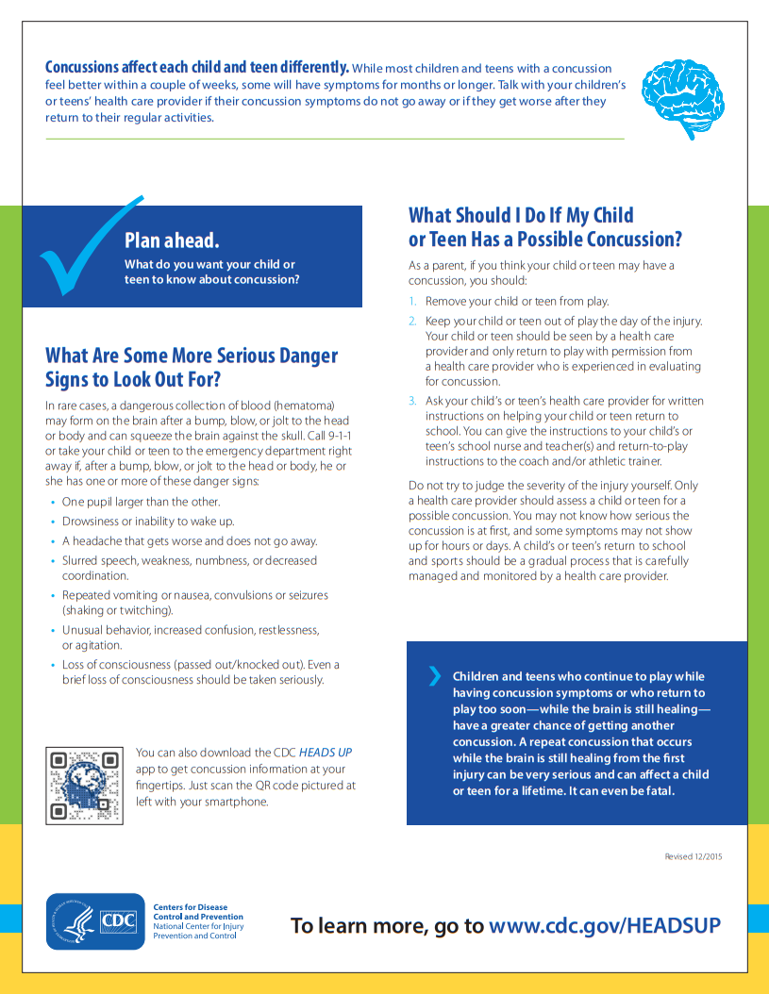

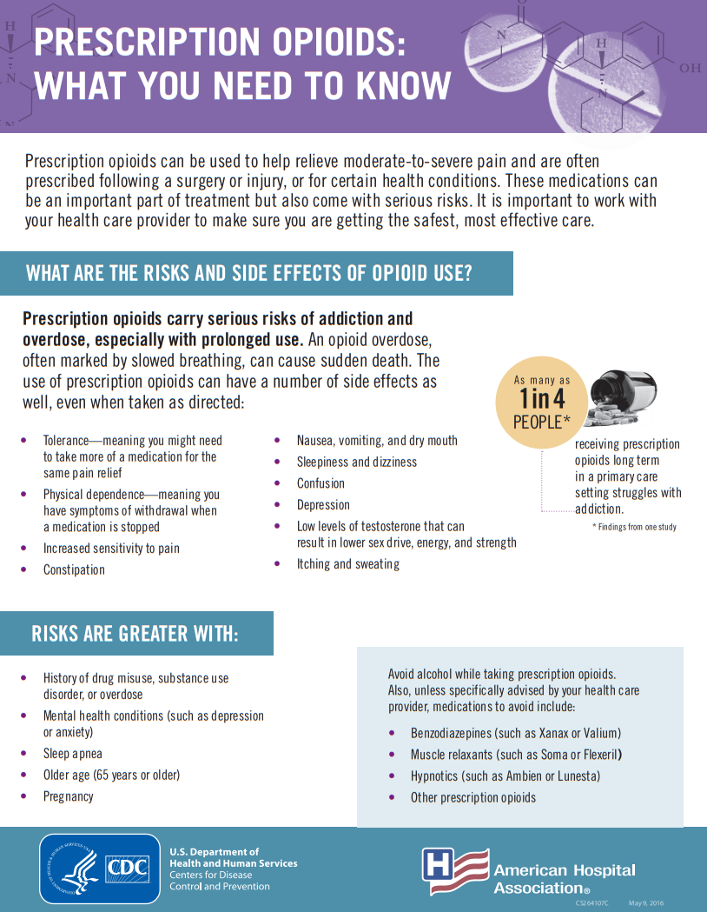

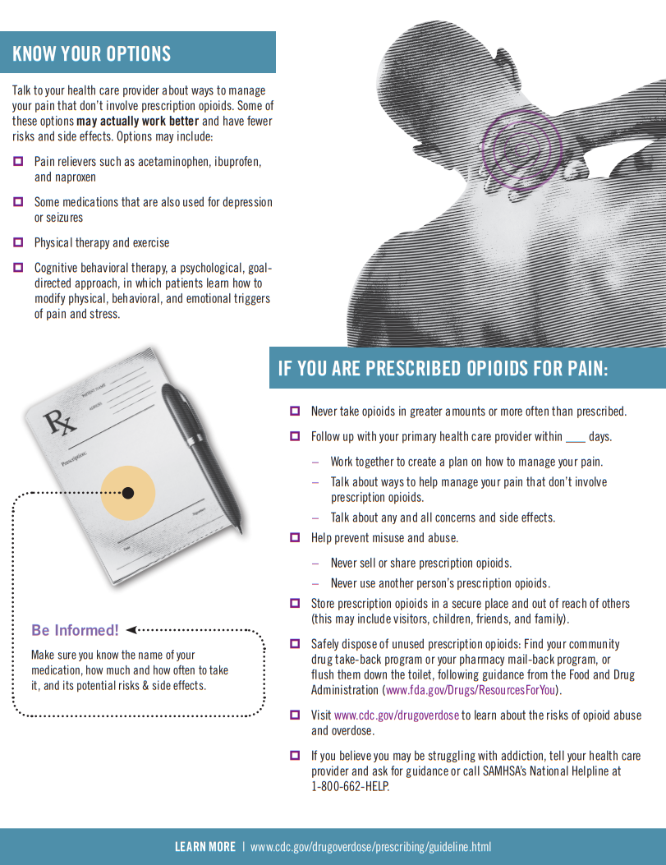

# Parent or legal guardian consent and acknowledgement form 1 of 2

_____________________________________ _____________________________________

Members Legal First Name Members Legal Last Name

**Member participation**

Every effort is made to provide members with a safe, enjoyable, and memorable experience. I attest and verify that my child is able to participate in all activities offered at the Boys & Girls Club of Laguna Beach. I understand that there are a variety of play areas at the Boys & Girls Club of Laguna Beach, including but not limited to: playgrounds, parks, gyms, art room, games room. I acknowledge that use of these various areas poses risks to my child, including the risk of sprains, bruises, broken bones and serious injury or death. I understand that my child will have access to all areas/activities of the facility that I enroll my child into. I, as parent/guardian of the minor, do hereby, for my child, myself, my heirs, executors and administrators, release and forever discharge and hold harmless the Boys & Girls Club of Laguna Beach and all officers, directors, employees, agents and volunteers of the organization, acting officially or otherwise, from any and all claims, demands, actions or causes of action which in any way arise from the minor’s participation and/or my participation at any of Boys & Girls Club of Laguna Beach facilities.

_____________________________________ _____________________________________

Parent / Guardian Name Parent / Guardian Signature

**Tell us how we can help your child be Successful**

1. What does your child/youth do that makes you smile?
2. What does your child/youth do that makes them smile?
3. What makes your child/youth sad or angry?
4. What does it look like when your child/youth is sad or angry?
5. What should we do when this happens?

# Parent or legal guardian consent and acknowledgement form 2 of 2

CLUB PROGRAM POLICY _______**Initials: Acknowledgment**

LATE PICK- UP POLICY _______**Initials: Acknowledgment**

MEMBER EXPECTATIONS _______**Initials: Acknowledgment**

Inclusion of All Children _______**Initials: Acknowledgment**

BULLYING POLICY _______**Initials: Acknowledgment**

Member Code of Conduct _______**Initials: Acknowledgment**

Discipline POLICY _______**Initials: Acknowledgment**

COMMUNICATION WITH SCHOOLS _______**Initials: Acknowledgment**

OUTCOMES MEASUREMENT _______**Initials: Consent OR Opt Out: _______Initials**

MENTORING PROGRAM _______**Initials: Consent OR Opt Out: _______Initials**

Health Policy _______**Initials: Acknowledgment**

Peanut and Tree Nut Free _______**Initials: Acknowledgment**

Transportation Policy _______**Initials: Acknowledgment**

YOUTH VENDOR PICK UP SERVICE _______**Initials: Acknowledgment**

Program Spaces _______**Initials: Acknowledgment**

Field Trip Policy _______**Initials: Acknowledgment**

PERMISSION TO PHOTOGRAPH _______**Initials: Consent OR Opt Out: _______Initials**

PHOTOGRAPH/ARTWORK _______**Initials: Consent OR Opt Out: _______Initials**

PUBLIC OUTSIDE OF CLUB _______**Initials: Acknowledgment**

TECHNOLOGY CONDUCT _______**Initials: Acknowledgment**

ATHLETICS DEPARTMENT _______**Initials: Received Electronic Flyers**

RESTROOM POLICY _______**Initials: Acknowledgment**

WEAPONS & DRUG-FREE ENVIROMENT _______**Initials: Acknowledgment**

Staff Code of Ethics _______**Initials: Acknowledgment**

Immediate Reporting _______**Initials: Acknowledgment**

**Parent/guardian Handbook**

I acknowledge that when signing and initialing this handbook once submitting it through DocHub or a hard copy of it, I am also able to save the PDF and print for my own records if submitting through DocHub. By reading signing, initialing and submitting the Boys & Girls Club of Laguna Beach Parent/ Guardian Safety Handbook, I understand the information therein. I agree to each of the terms, consent the acknowledgments regarding the Member and Parent/Guardian Safety Handbook. In order to participate at the Boys & Girls Club of Laguna Beach, I the legal parent/guardian that is signing the consent acknowledgment form agrees to permit listed child to participate in all activities and areas of the facility.

_______________________________ __________________________________ _________________

Parent / Guardian Name (Printed) Parent / Guardian Signature Date